EXPERIMENT 10
1. AIM:
To understand and design Business Intelligence deployment, monitoring, backup, and recovery strategies using Microsoft Power BI for ensuring availability, reliability, and continuity of BI solutions.
2. OBJECTIVES:
• Identify BI assets that need to be deployed and maintained.
• Prepare a deployment plan for reports, dashboards, datasets, and workspaces.
• Design workspace structures, roles, responsibilities, and governance guidelines.
• Identify monitoring requirements for refresh status, usage, performance, and user activity.
• Develop backup schedules and restore procedures for BI assets.
• Plan disaster recovery and business continuity actions for a critical dashboard.
3. TOOLS / SOFTWARE REQUIRED:
• Microsoft Power BI Desktop
• Microsoft Power BI Service
• Global Superstore Dataset.xlsx
• Microsoft Excel
• Microsoft PowerPoint (Optional)
4. DATASET USED: Global Superstore Dataset.xlsx.
5. THEORY:
• Business Intelligence systems must be deployed, monitored, maintained, and protected to ensure continuous business operations.
• BI Deployment refers to making reports, dashboards, and analytical solutions available to end users.
• Monitoring involves tracking system performance, usage, refresh status, and operational health.
• Backup and Restore mechanisms protect BI assets from accidental deletion, corruption, or system failures.
• Effective deployment and maintenance strategies improve reliability, security, and business continuity.
6. PROCEDURE:
Part A: BI Deployment Planning
Step 1: Identify BI assets created in previous experiments.
Review the Power BI files and materials developed in previous experiments, including reports, dashboards, datasets, security plans, and automated reporting plans.
Step 2: List assets that require deployment.
Create an inventory table in Microsoft Excel with columns for Asset Name, Asset Type, Owner, Intended Users, and Deployment Status. Include relevant reports, dashboards, datasets, and workspaces.
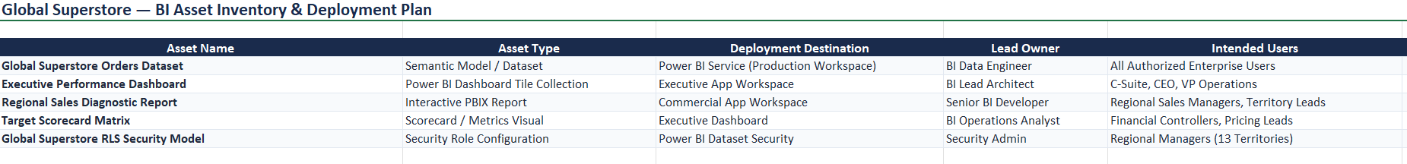
Fig 10.1: BI asset inventory
Step 3: Create a BI Deployment Plan.
Prepare a plan describing each asset, its deployment destination, responsible person, deployment sequence, and validation method.
Step 4: Identify intended users and departments.
List the departments and users who will use the BI solution, such as executive management, Sales, Finance, and regional management. Match each group with the reports it needs.
Step 5: Define deployment objectives and expected outcomes.
Document the objectives, such as making approved reports available, ensuring appropriate access, maintaining data freshness, and supporting timely business decisions.
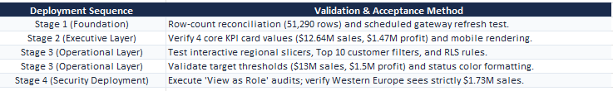
Fig 10.2: BI deployment plan
Part B: Workspace and Access Planning
Step 6: Design a Power BI Workspace structure.
Plan a workspace structure for the organization. Identify which reports, dashboards, and datasets belong in each workspace and how content will be organized.
Step 7: Identify workspace roles.
List the Power BI workspace roles: Administrator, Member, Contributor, and Viewer. Use the roles specified in the experiment to plan access.
Step 8: Assign responsibilities to each role.
Prepare a table mapping each role to its responsibilities. For example, administrators manage workspace settings and access, while viewers primarily consume reports. Assign only the access needed for each responsibility.
Step 9: Document workspace governance guidelines.
Write guidelines for naming workspaces, assigning owners, approving access, publishing changes, reviewing permissions, and maintaining documentation.
Fig 10.3: Workspace structure and role plan
Part C: Monitoring Strategy Design
Step 10: Identify monitoring requirements.
List the operational items to monitor: dataset refresh status, dashboard usage statistics, report performance, and user activity monitoring.
Step 11: Create a Monitoring Matrix.
In Excel, create columns for Monitoring Metric, What to Check, Monitoring Frequency, Responsible Personnel, and Action if an Issue Occurs. Add an entry for each monitoring requirement.
Step 12: Define follow-up actions for monitoring issues.
Describe the response to common issues, such as investigating failed refreshes, reviewing slow report performance, checking unexpected usage patterns, and escalating unresolved problems.
Fig 10.4: Monitoring matrix
Part D: Backup and Restore Planning
Step 13: Identify BI components that require backup.
List important BI assets such as dataset/source files, Power BI Desktop project files, report definitions, documentation, workspace configuration records, and supporting deployment materials.
Step 14: Develop a Backup Schedule.
Create a schedule based on the experiment examples: daily dataset backup, weekly report backup, and monthly workspace archive. Record the backup owner, storage location, and verification method.
Step 15: Design a Restore Procedure.
Write a recovery sequence for accidental deletion or system failure: identify the missing or damaged asset, locate the latest valid backup, restore or republish the asset using the appropriate supported method, verify report functionality and data, and document the recovery.
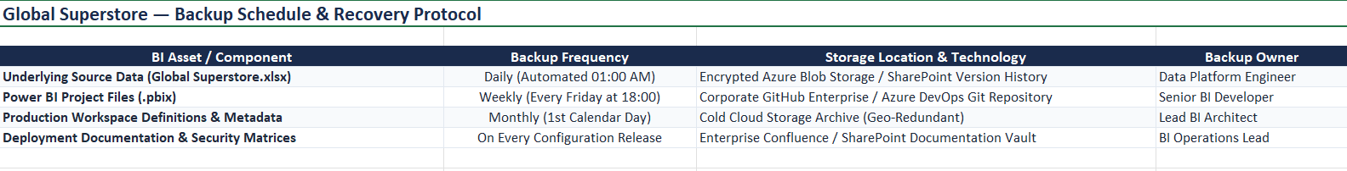
Fig 10.5: Backup schedule and restore procedure
Part E: Disaster Recovery Scenario
Step 16: Analyze the disaster recovery scenario.
Consider the scenario: “A critical executive dashboard is accidentally deleted one day before a management meeting.” Identify the business impact, required dashboard, source report or file, and people responsible for recovery.
Step 17: Explain how backup and restore procedures recover the solution.
Locate the latest available backup or source report, restore or republish the dashboard/report as appropriate, reconnect or validate the dataset if needed, and check that visuals and permissions work correctly.
Step 18: Document business continuity actions.
List actions such as notifying the dashboard owner and management, prioritizing restoration, validating key KPIs, providing a temporary approved report if necessary, and recording the incident and preventive measures.
Fig 10.6: Disaster recovery and business continuity plan
Part F: Final Review and Validation
Step 19: Review the deployment plan.
Confirm that all required BI assets, intended users, deployment objectives, and responsible personnel are documented.
Step 20: Review workspace governance and monitoring.
Check that workspace roles and responsibilities are defined and that each monitoring metric has a frequency, owner, and follow-up action.
Step 21: Review backup and recovery readiness.
Verify that the backup schedule, restore steps, disaster recovery actions, and required deliverables are clearly documented.
7. RESULT:
A complete BI deployment, monitoring, backup, and recovery strategy was designed. Deployment plans, workspace structures, monitoring procedures, and backup mechanisms were documented to support reliable and secure BI operations.
8. LEARNING OUTCOMES:
• Analyzed deployment requirements for Business Intelligence solutions. (CO4-BT4)
• Designed workspace structures and governance models for BI systems. (CO5-BT6)
• Evaluated monitoring requirements for deployed BI solutions. (CO4-BT4)
• Developed backup and recovery strategies for business continuity. (CO5-BT6)
• Designed a deployment and maintenance plan for an organizational BI environment. (CO5-BT6)
9. DELIVERABLES:
• BI Deployment Plan
• Workspace and Role Structure Diagram
• Monitoring Matrix
• Backup and Recovery Plan
• Disaster Recovery Report
10. TEXT / REFERENCE BOOKS:
• Sharda, Delen & Turban, Business Intelligence and Analytics.
• Rick Sherman, Business Intelligence Guidebook.
• Microsoft Power BI Administration and Deployment Documentation.
• Cindi Howson, Successful Business Intelligence.

